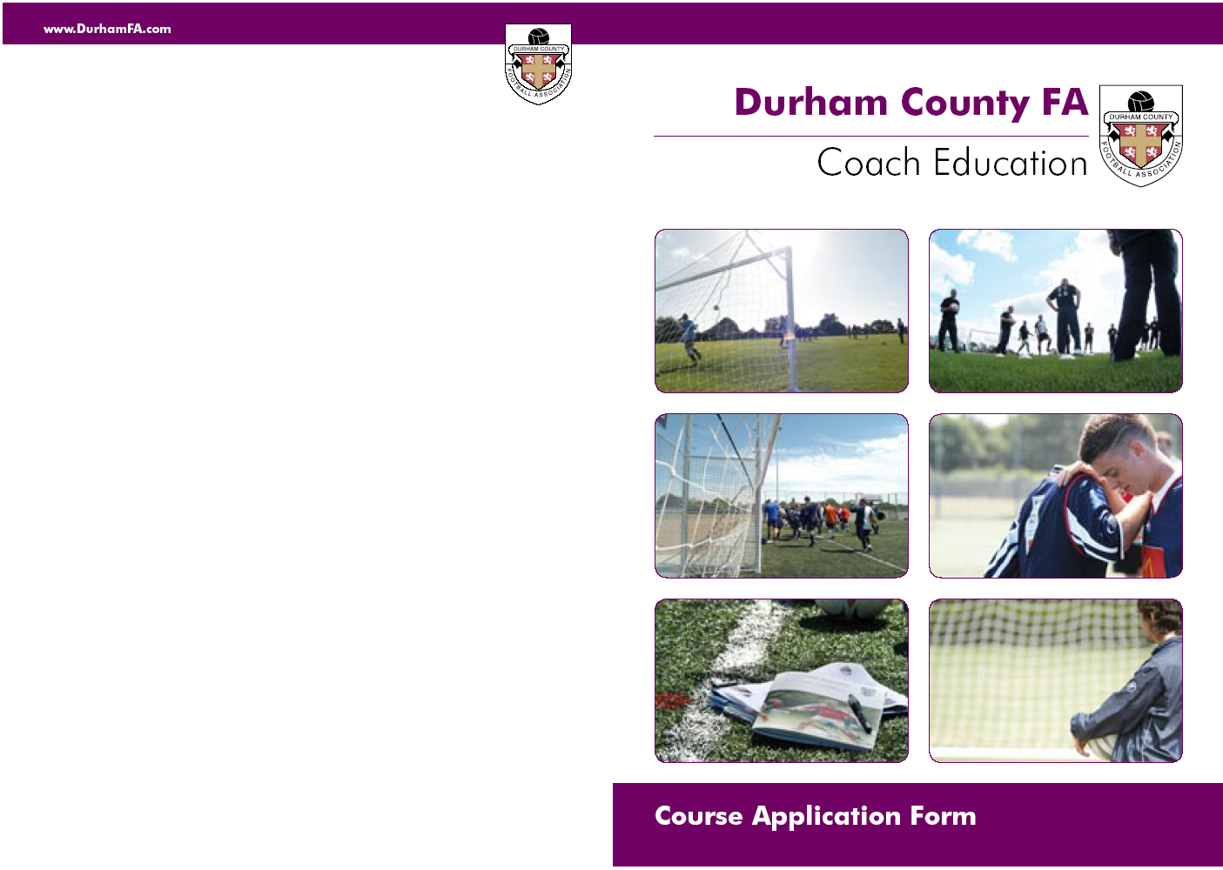


FA Coaching Adults Course
______________________________________________________________________
Venue: Houghton Kepier Sports College, Dairy Lane, Houghton le Spring, DH4 5BH
______________________________________________________________________
2012
Monday 2nd July 6.00pm – 9.00pm
Saturday 7th July 9.30am – 5.00pm
(Both Sessions must be attended)
______________________________________________________________________
Course Syllabus:- Attendance of all sessions
Theory Tasks
Practical Activities and Games
Non Assessment Criteria
______________________________________________________________________________
Cost: FREE for coaches from FA Charter Standard Clubs
(Part of FA Charter Standard Coach Education Programme sponsored by McDonalds)
Terms and conditions apply:
- Club must be affiliated to Durham County FA
- Club must have a signed off and fully completed FA Charter Standard Club Health Check (Coach must be added to Club Records through Member Services)
- All application forms must be co-signed by a club secretary, otherwise application form will be returned.
- If candidates fails to attend without informing Durham County FA or fails to complete the course, the FULL COST of £30 per candidate will be charged
_____________________________________________________________________________
Tel: 0191 3872928

E-mail: development@durhamfa.com Web: www.durhamfa.com

COURSE CODE: 1CAF06
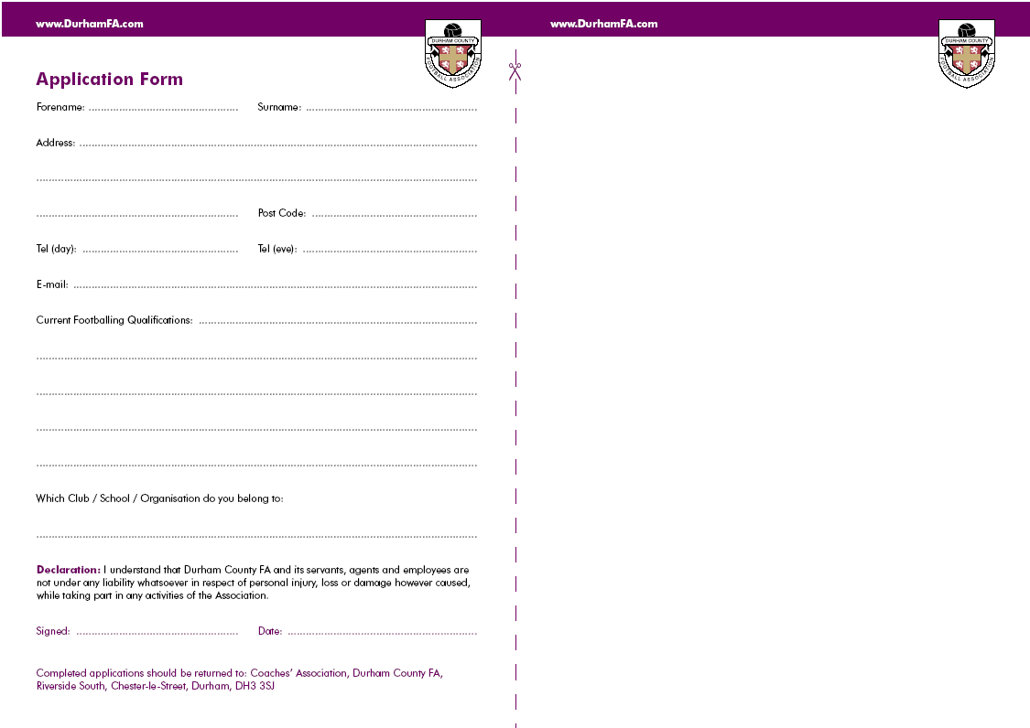
Durham FA Coach Education Cancellation Policy

If you need to cancel your attendance on the course you should inform Durham FA immediately. All our courses are in demand and by not advising us you are preventing another candidate from attending.

If you cancel more than 2 weeks prior to the commencement of the course, a full refund will be issued. However, if you cancel after the 2 week deadline, no refund will be given. Consideration will be given to candidates who, for health reasons are unable to attend and require a transfer to another course. A letter from a doctor or medical professional must be supplied.

If you should decide to transfer to another course once your application has been submitted, there will be an additional administration charge of £20.00

By submitting an application you agree to all of the terms above
Getting your
Guidance Notes

If you are a League Official, Club Official, Referee, Coach and/or Player it is extremely likely you have a FAN already.
Please email: GetOnline@TheFA.com with your name, date of birth and address and your FAN and password will
be emailed to you.

You can also register for a FAN at www.TheFA.com/FAN

Course Code: 1CAF06
Title: …………..
Forename: ………………………………………… Surname: ………………………………………………..

Address: ………………………………………………………………………………………………………………….

………………………………………………………………………………… Post Code: ..………………………..

Date of Birth: ……../……../………. Tel : …………………………………………………….
FAN must be complete. If you do not know your FAN please see guidance notes

E-mail: …………………………………………………………………………………………………………………….

Disability/Medical Condition: …………………………………………………………………………………..

Which Club / School / Organisation do you belong to:
(Team Name)……………………………………………………………………….(Age Group)…………………………
Declaration: I understand that Durham County FA and its servants, agents and employees are not under any liability whatsoever in respect of personal injury, loss or damage however caused, while taking part in any activities of the Association. I have read and agree to the Durham County FA Coach Education Cancellation Policy. Policy available from www.durhamfa.com/development/courses

Signed: ………………………………………………………. Date: …………………………………

Completed applications should be returned to: Durham County FA,
Football Development, Riverside South, Chester-le-Street, DH3 3SJ

FA Coaching Adults Course

Course Duration: 10 hours
Course aims and objectives: The course provides an introduction for coaches and managers who are involved in adult football and comprises various elements.
The course will address the following:
- Administration and best practice
- Health and Safety
- Players development
- Fitness and Nutrition
- Warm up / Cool down
- Fitness Ideas
- Ethics / role of coaches / managers / administration
- Where next? Future training opportunities.
Course Content
Practical Involvement: Candidates will be encouraged to participate practically to maximise their opportunities for learning (This however will not prevent successful completion of the award).
Assessment: There is no formal assessment; the progress of learners is monitored through the group activities and discussions.

