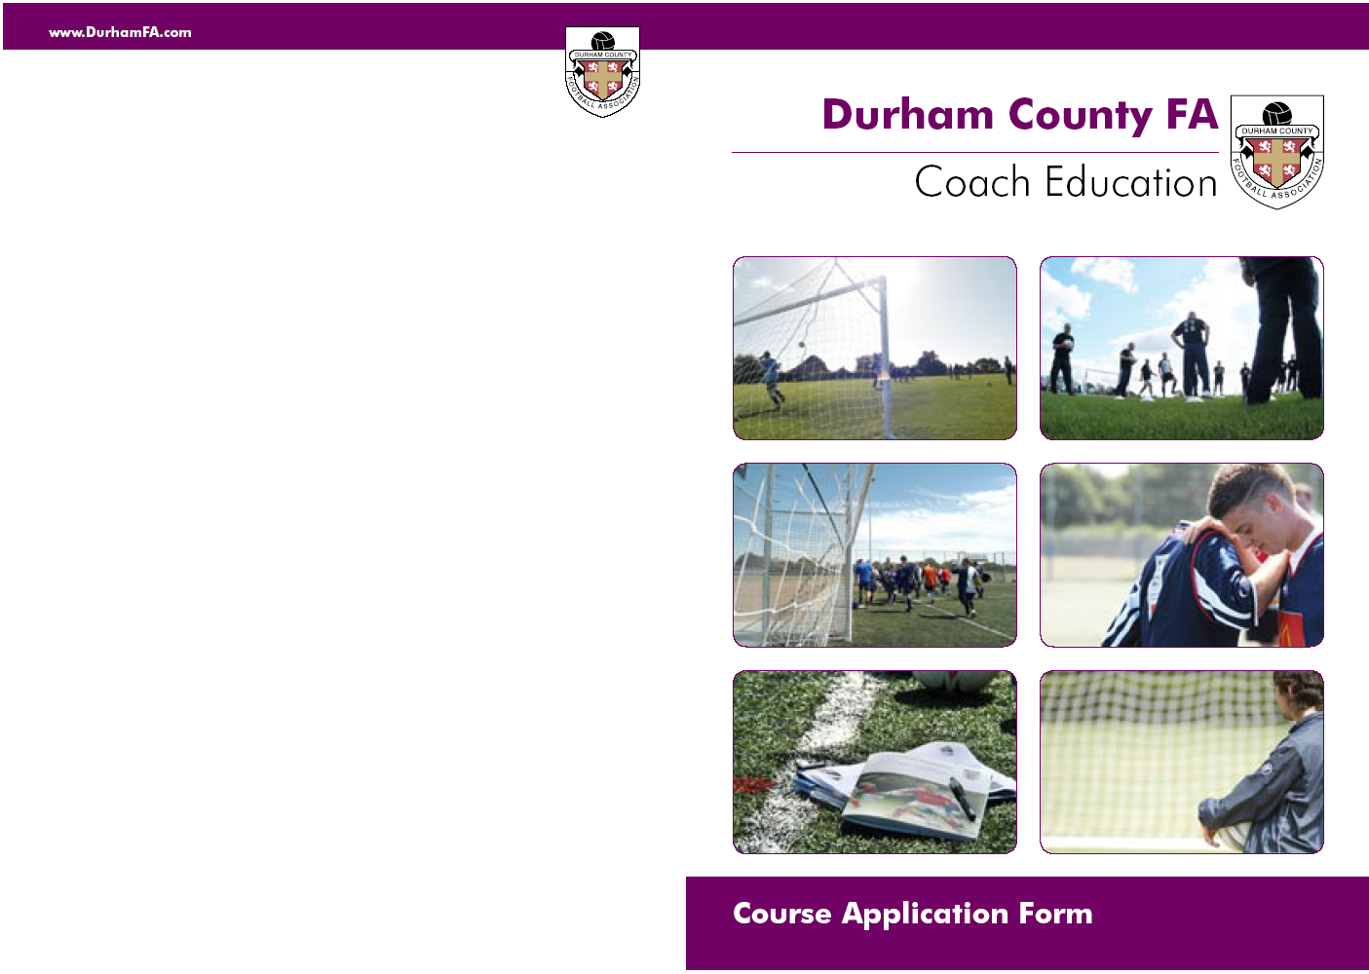

Football Association

Emergency 1st Aid Workshops 2012

Houghton Kepier Sports College, Dairy Lane, DH4 5BH
Date: Thursday 9th February 2012 6.00 – 9.00pm
COURSE CODE: EM838
Norton & Stockton Ancients, Norton Sports Complex, Station Road, Norton, TS20 1PE
Date: Monday 5th March 2012 6.00 – 9.00pm
COURSE CODE :- EM839

Stanley School of Technology, Tyne Road, Stanley, Co Durham DH9 6PZ
Date: Monday 26th March 2012 6.00 – 9.00pm
COURSE CODE: EM840

Greenfield School, Greenfield Way, Newton Aycliffe, DL5 7LE
Date: Wednesday 3rd May 2012 6.00 – 9.00pm
COURSE CODE: EM841

Primrose Community Centre, Lambton Terrace, Jarrow, NE32 5QY
Date: Monday 28th May 2012 6.00 – 9.00pm
COURSE CODE: EM842

Norton & Stockton Ancients, Norton Sports Complex, Station Road, Norton, TS20 1PE
Date: Thursday 5th July 2012 6.00 – 9.00pm
COURSE CODE: EM843

Houghton Kepier Sports College, Dairy Lane, DH4 5BH
Date: Tuesday 31st July 2012 6.00 – 9.00pm
COURSE CODE: EM844

Hummersknott School & Language College, Edinburgh Drive, Darlington DL3 8AR
Date: Tuesday 4th September 2012 6.00 – 9.00pm
COURSE CODE: EM845

Gateshead Cleveland Hall FC, Beacon Lough Rd, Gateshead, NE9 6TA
Date: Wednesday 3rd October 2012 6.00 – 9.00pm
COURSE CODE: EM846

Caterpillar UK. Learning Centre of Light, Judson Road, North West Ind Est Peterlee, SR8 2QS
Date: Tuesday 6th November 2012 6.00 – 9.00pm
COURSE CODE: EM847

Cost:- £20 per candidate, Cheques & Postal orders made payable to Durham County FA Ltd

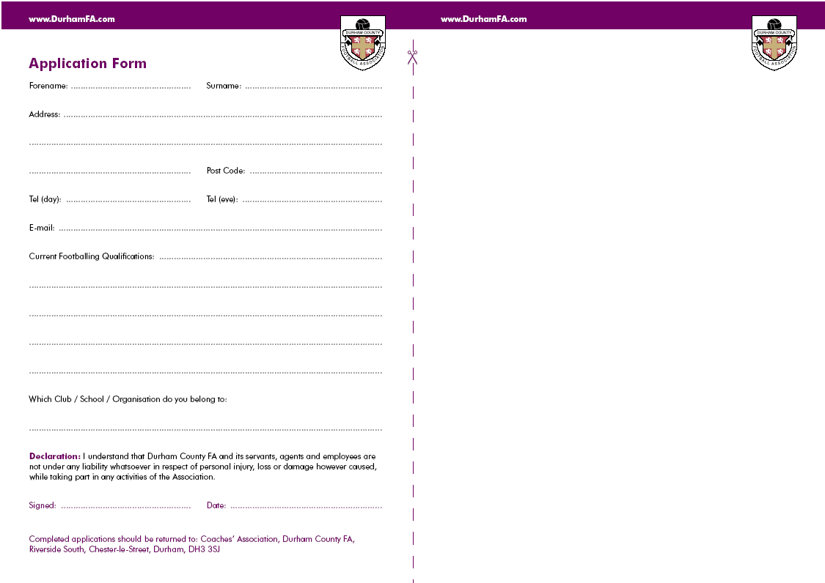
Durham FA Coach Education Cancellation Policy

If you need to cancel your attendance on the course you should inform Durham FA immediately. All our courses are in demand and by not advising us you are preventing another candidate from attending.

If you cancel more than 2 weeks prior to the commencement of the course, a full refund will be issued. However, if you cancel after the 2 week deadline, no refund will be given. Consideration will be given to candidates who, for health reasons are unable to attend and require a transfer to another course. A letter from a doctor or medical professional must be supplied.

If you should decide to transfer to another course once your application has been submitted, there will be an additional administration charge of £20.00

By submitting an application you agree to all of the terms above
Getting your
Guidance Notes

If you are a League Official, Club Official, Referee, Coach and/or Player it is extremely likely you have a FAN already.
Please email: GetOnline@TheFA.com with your name, date of birth and address and your FAN and password will
be emailed to you.

You can also register for a FAN at www.TheFA.com/FAN

Course Code: EM

THE FOOTBALL ASSOCIATION
Emergency 1st Aid Workshop

For whom the course is intended

Males or Females
Minimum age is 16 years
Managers/Coaches of junior football teams
Mini-Soccer organisers and officials
Youth Leaders and Prospective Youth Leaders
College and University Students
School sixth form students
Volunteers within football clubs

Course Content

This workshop is a 3 hour module that covers the basics of administering emergency first aid procedures.

The workshop will cover the following:

Primary Survey
Secondary Survey
The Recovery Position
CPR (Cardio Pulmonary Resuscitation) for both children and adults

How to apply to attend?

Simply indicate which course you would like to attend by completing the opposite application including the course code

:
Forename: …………………………………………….. Surname: …………………………………………….

Address: ………………………………………………………………………………………………………………….

………………………………………………………………………………… Post Code: ..………………………..

Date of Birth: ……../……../………. Tel : …………………………………………………….

FAN must be complete. If you do not know your FAN please see guidance notes

E-mail: …………………………………………………………………………………………………………………….

Disability/Medical Condition: …………………………………………………………………………………..

Which Club / School / Organisation do you belong to:
……………………………………………………………………………………………………………………..
Declaration: I understand that Durham County FA and its servants, agents and employees are not under any liability whatsoever in respect of personal injury, loss or damage however caused, while taking part in any activities of the Association. I have read and agree to the Durham County FA Coach Education Cancellation Policy. Policy available from www.durhamfa.com/development/courses

Signed: …………………………………………….. Date: ……………………….

Completed applications should be returned to: Durham County FA,
Football Development, Riverside South, Chester-le-Street, DH3 3SJ
