Completing Charter Standard Health Check
Go to DFA website:
http://www.durhamfa.com/

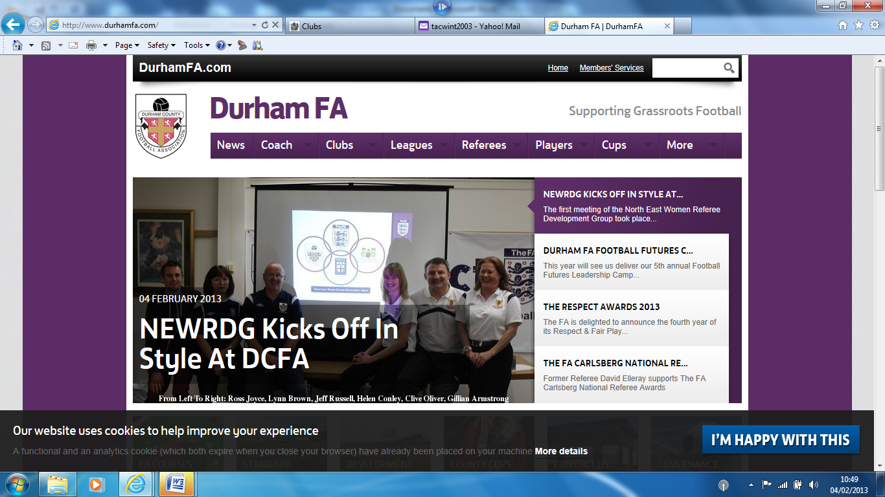
Go to Members’ Services
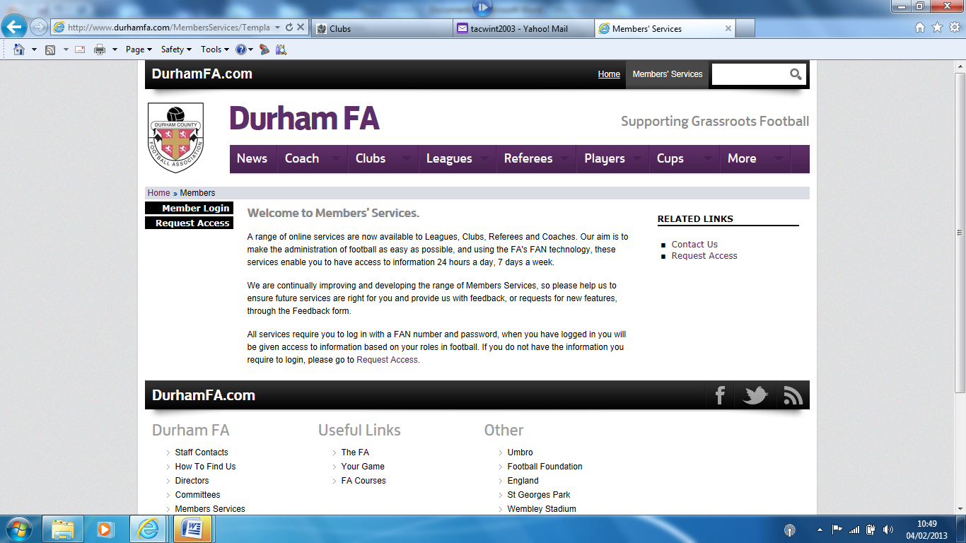
If you have login details go to Member Login, if not go to Request Access
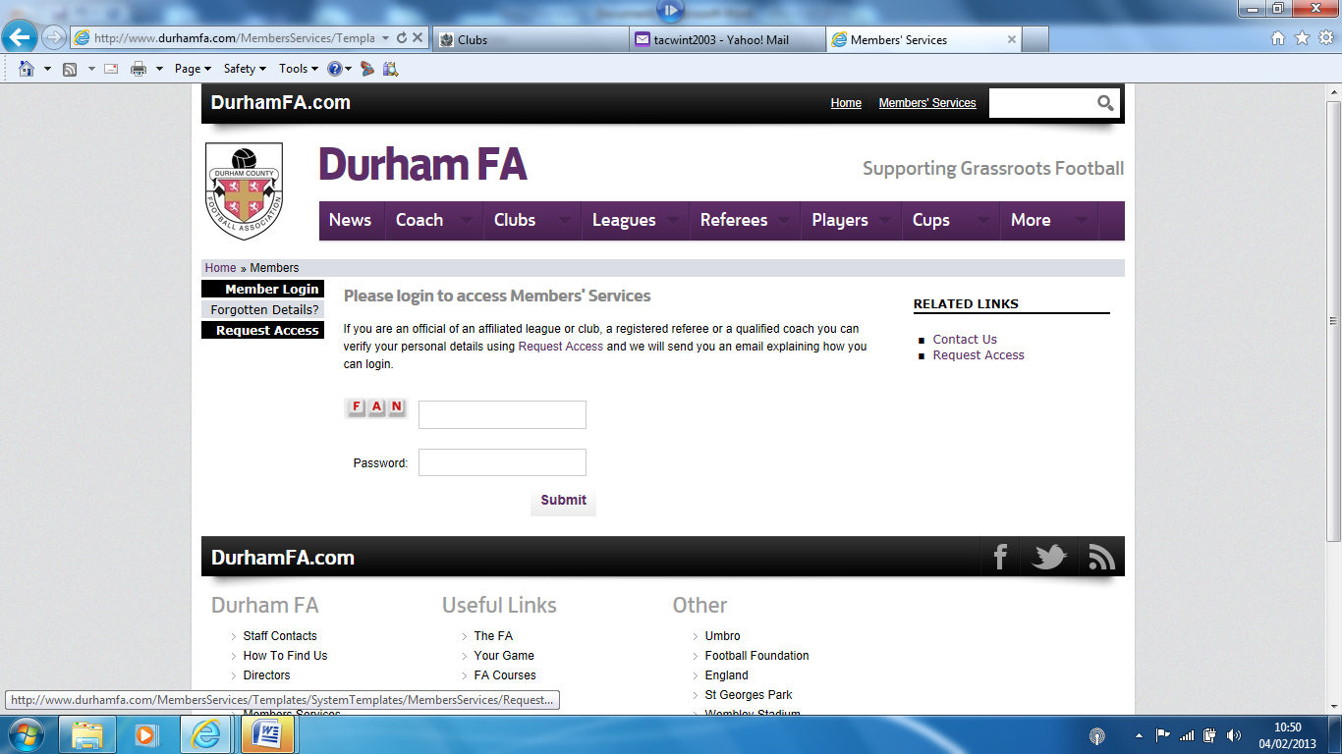

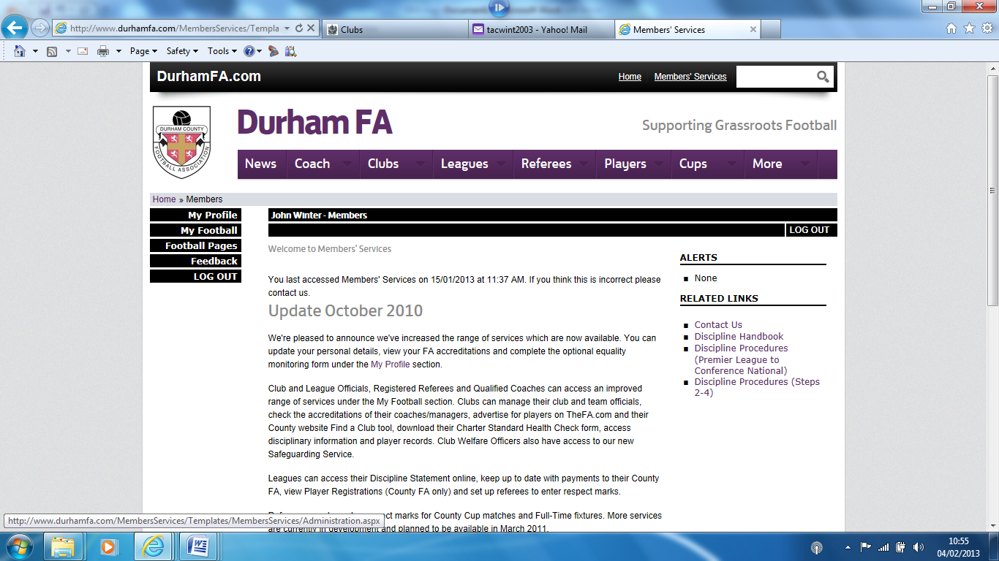
Go to My Football

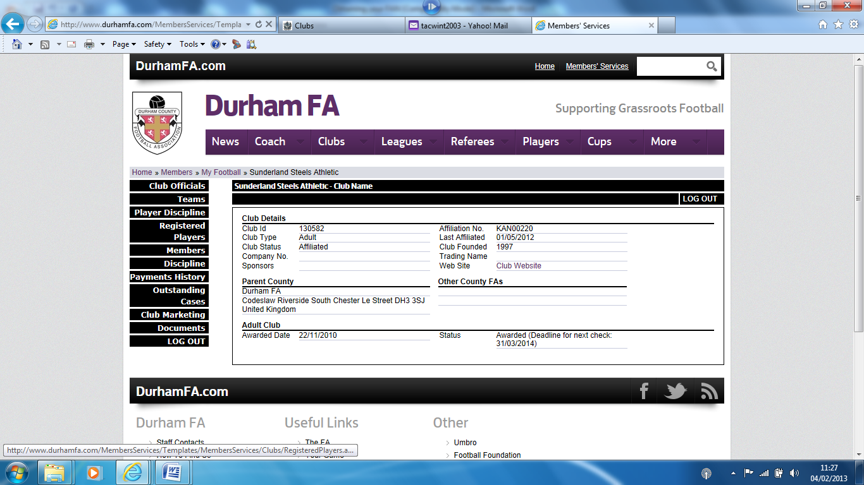
Go to Club Officials
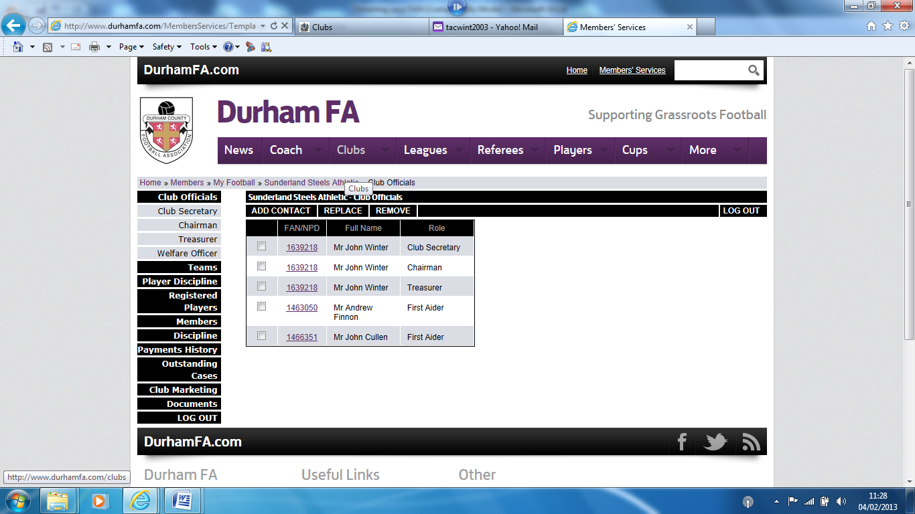
Update as necessary – especially your first aiders – then go to Documents

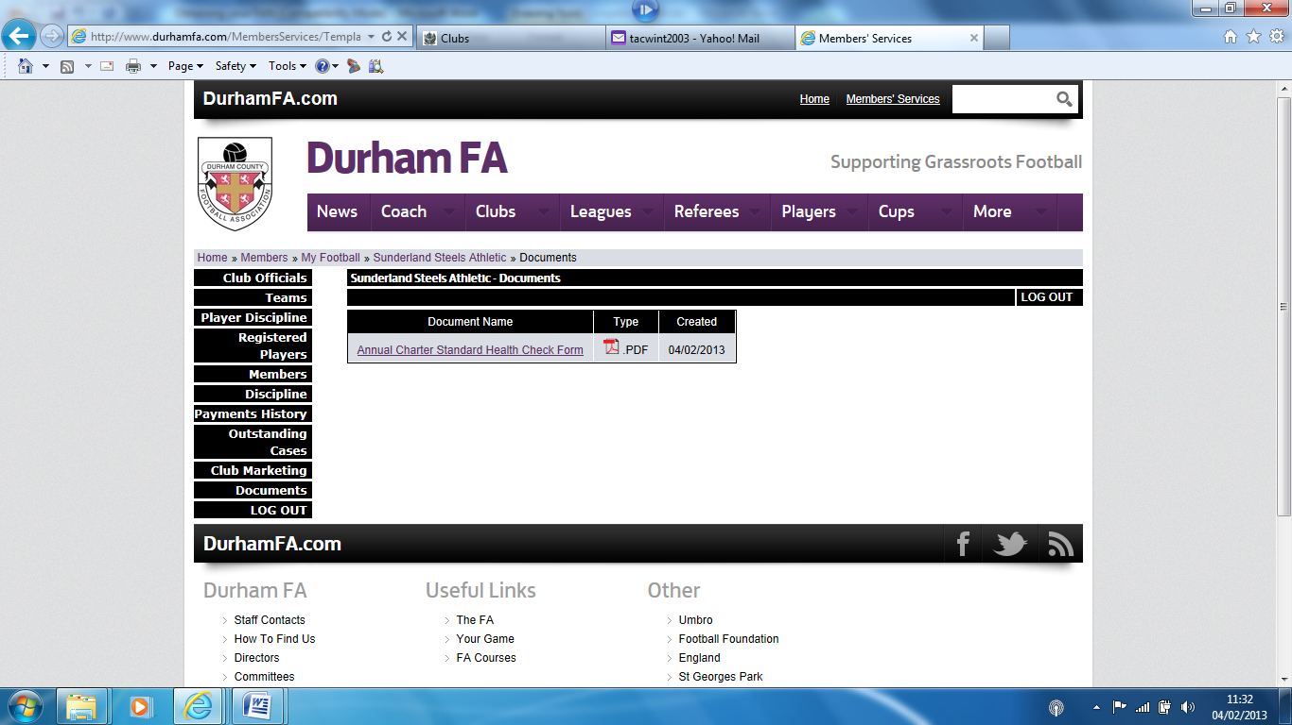
Open Health Check form and print
Complete form and send to:
Andrew Brown
Football Development Officer-Club Development
Durham County FA
'Codeslaw'
Riverside South
Chester Le Street
DH3 3SJ

